IXXAT CAN-USB CONVERTER

2 - can - low

3 - gnd

7 - can - high

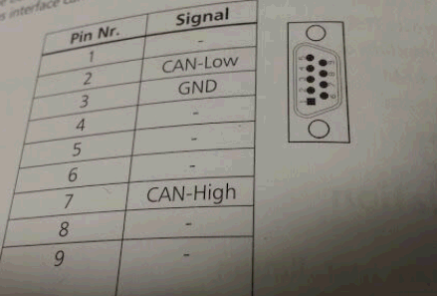

SEVCON

24/27 = CAN LOW

2 = CAN TERMINATION

13/16 = CAN HIGH

GND = BATT NEG

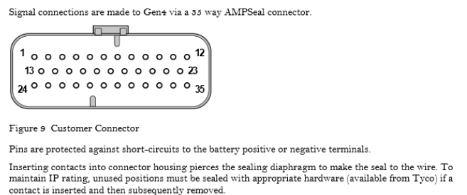

CONNECTION

Ixxat sevcon

2 - 2 + 24/27 \*\*twisted\*\*

3 - battery gnd

7 - 13/16 \*\*twisted\*\*